Associations between detection of enteropathogens and microbial source tracking markers in the environment and child enteric infections and growth: an individual participant data meta-analysis

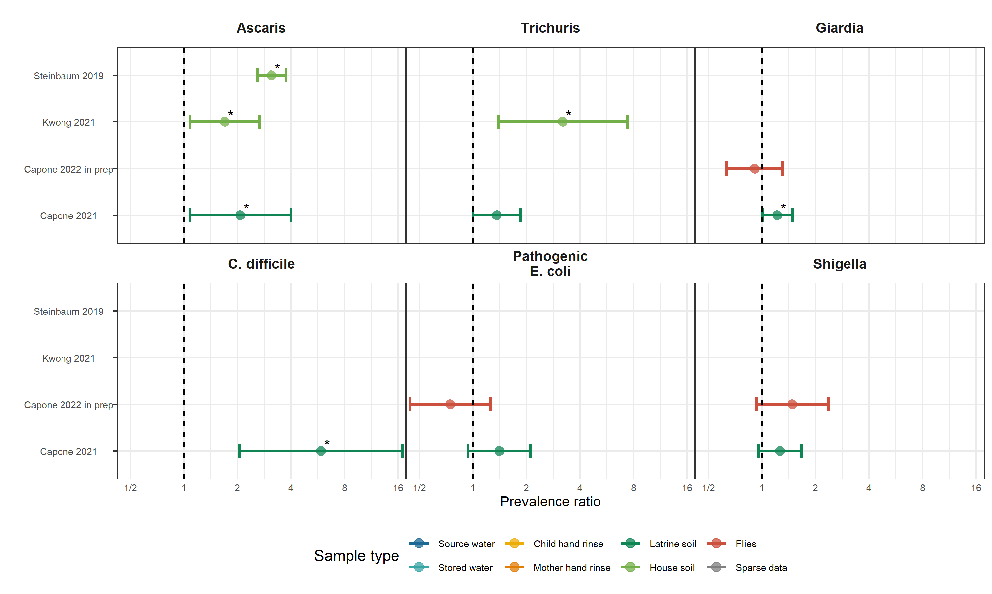

**Figure 1.** Forest plots of associations between specific enteropathogens in environmental samples and child infections with the same enteropathogens. The presented prevalence ratios compare the detection prevalence of a pathogen in stool between children from compounds where the pathogen was detected vs. not detected in environmental samples. Samples of the same type from different locations (source vs. stored water, flies in kitchen vs. latrine, soil from courtyard vs. latrine) or different individuals (child vs. mother’s hands) are plotted separately and denoted by different colors. All estimates are adjusted for potential confounders.

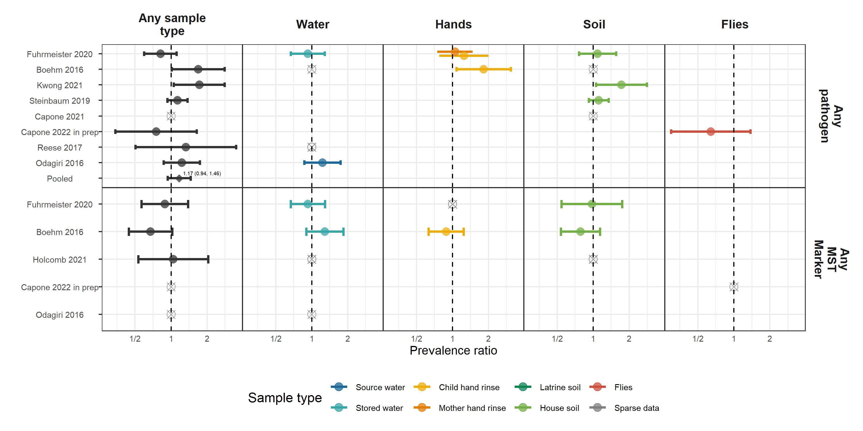

**Figure 2.** Forest plots of associations between the prevalence of any enteropathogen or any MST markers in different types of environmental samples and child diarrheal disease. The presented prevalence ratios compare diarrhea prevalence between children from compounds where any pathogen/MST marker was detected vs. not detected in environmental samples. Pooled estimates are presented when there are four or more study-specific estimates for a specific sample type and target combination and are denoted with diamond-shaped points. Grey crossed points denote data that were too sparse to estimate a prevalence ratio (i.e., <10 positive or negative observations). Samples of the same type from different locations (source vs. stored water, flies in kitchen vs. latrine, soil from courtyard vs. latrine) or different individuals (child vs. mother’s hands) are plotted separately. Asterisks above estimates denote statistical significance (*= P-value < 0.05, **= P-value < 0.01, ***= P-value < 0.001). All estimates are adjusted for potential confounders.

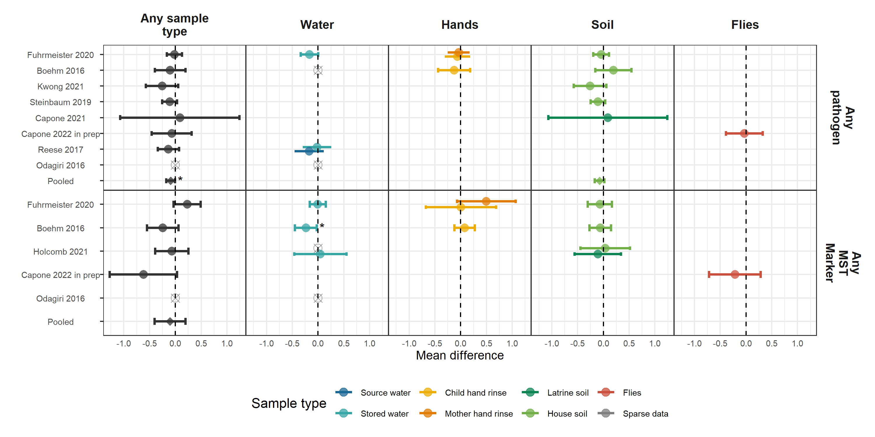

**Figure 3.** Forest plots of associations between the prevalence of any enteropathogen or any MST markers in different types of environmental samples and heigh-for-age Z-scores (HAZ). The presented differences compare HAZ between children from compounds where any pathogen/MST marker was detected vs. not detected in environmental samples. Pooled estimates are presented when there are four or more study-specific estimates for a specific sample type and target combination and are denoted with diamond-shaped points. Grey crossed points denote data that were too sparse to estimate a mean difference. Samples of the same type from different locations (source vs. stored water, flies in kitchen vs. latrine, soil from courtyard vs. latrine) or different individuals (child vs. mother’s hands) are plotted separately. Asterisks above estimates denote statistical significance (*= P-value < 0.05, **= P-value < 0.01, ***= P-value < 0.001). All estimates are adjusted for potential confounders.

**Table 1.** Descriptive statistics of child health outcomes by study. Pathogen-specific infection prevalence is the prevalence of at least one pathogen detected in child stool, and the number of pathogen infections is the total number of detected infections, where individual children can have infections from multiple pathogens.

| **Study** | **Trial** | **Distinct pathogens measured** | **# children with pathogens measured** | **# pathogen infections** | **Pathogen prev.** | **# diarrhea obs.** | **# diarrhea cases** | **Diarrhea prev.** | **# HAZ obs.** | **Mean HAZ** | **Stunting prev.** | **# WAZ obs.** | **Mean WAZ** | **Underweight prev.** | **# WHZ obs.** | **Mean WHZ** | **Wasting prev.** |
| --- | --- | --- | --- | --- | --- | --- | --- | --- | --- | --- | --- | --- | --- | --- | --- | --- | --- |
| Reese 2017 | Gram Vikas |  |  |  |  | 210 | 17 | 8.1 | 578 | -1.78 | 42.2 |  |  |  | 576 | -0.87 | 13.4 |
| Holcomb 2021 | MapSan |  |  |  |  | 227 | 20 | 8.8 | 232 | -1.74 | 49.1 | 231 | -0.64 | 10.8 | 228 | 0.21 | 7.0 |
| Capone 2021 | MapSan | 15 | 246 | 1,009 | 87.1 | 289 | 33 | 11.4 | 317 | -1.55 | 40.7 | 321 | -0.66 | 12.1 | 309 | 0.08 | 9.4 |
| Capone 2022 in prep | MapSan | 10 | 255 | 803 | 82.2 | 244 | 27 | 11.1 | 291 | -1.67 | 42.3 | 293 | -0.69 | 14.3 | 280 | 0.14 | 7.1 |
| Odagiri 2016 | Odisha |  |  |  |  | 2,036 | 188 | 9.2 |  |  |  | 4,152 | -1.38 | 29.1 |  |  |  |
| Fuhrmeister 2020 | WBB | 2 | 89 | 34 | 19.1 | 1,598 | 189 | 11.8 | 858 | -1.81 | 40.9 | 872 | -1.54 | 30.5 | 860 | -0.85 | 10.0 |
| Boehm 2016 | WBB |  |  |  |  | 412 | 99 | 24.0 | 411 | -1.35 | 26.3 | 412 | -1.35 | 24.3 | 412 | -0.74 | 9.5 |
| Kwong 2021 | WBB | 2 | 1,243 | 615 | 33.1 | 1,080 | 141 | 13.1 | 103 | -1.58 | 30.1 | 103 | -1.55 | 29.1 | 103 | -0.97 | 8.7 |
| Steinbaum 2019 | WBK | 2 | 1,609 | 338 | 20.6 | 1,912 | 496 | 25.9 | 1,800 | -1.54 | 31.6 | 1,852 | -0.73 | 9.7 | 1,797 | 0.10 | 1.5 |

HAZ: Height-for-age Z-score; WAZ: Weight-for-age Z-score; WHZ: Weight-for-height Z-score.